Confusion Matrix

[View all machine learning examples](https://www.mathworks.com/solutions/machine-learning/examples.html)

This example demonstrates how a confusion matrix can be used to assess the performance of a classifier. All off-diagonal elements on the confusion matrix represent misclassified data. A good classifier will yield a confusion matrix that will look dominantly diagonal.

Visualization generated using [Customizable Heat Maps](https://www.mathworks.com/matlabcentral/fileexchange/24253-customizable-heat-maps).

Load Data

load fisheriris

The variable meas contains measurements on the sepal length, sepal width, petal length, and petal width for 150 iris specimens from the following three species :

labels = unique(species);

disp(labels)

'setosa'

'versicolor'

'virginica'

Train a Linear Discriminant Analysis (LDA) Classifier

mdl = ClassificationDiscriminant.fit(meas,species);

Predict Species Using the LDA Model

predicted_species = predict(mdl,meas);

You can predict the response for the same data used to train the classifier. This is also known as prediction by resubstitution. Alternative syntax to do the above is to call resubPredict .

predicted_species = resubPredict(mdl);

Compute and Visualize the Confusion Matrix

Conf_Mat = confusionmat(species,predicted_species);

disp(Conf_Mat)

50 0 0

0 48 2

0 1 49

We can visualize the same using a heat map.

heatmap(Conf_Mat, labels, labels, 1,'Colormap','red','ShowAllTicks',1,'UseLogColorMap',true,'Colorbar',true);

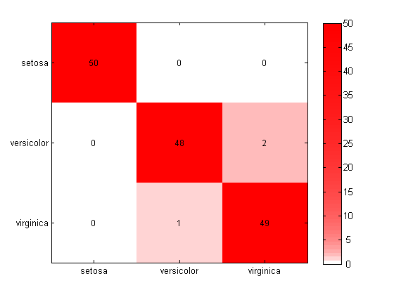

This visualization has been generated using [Customizable Heat Maps](https://www.mathworks.com/matlabcentral/fileexchange/24253-customizable-heat-maps).

Interpreting the Confusion Matrix

* Two observations of versicolor were misclassified as virginica .
* One observation of virginica was misclassifed as versicolor .

Datasets and References

Fisher's iris data consists of measurements on the sepal length, sepal width, petal length, and petal width for 150 iris specimens. There are 50 specimens from each of three species. This dataset is shipped with the [Statistics and Machine Learning Toolbox™](https://www.mathworks.com/products/statistics.html) .